

Final Report

Topic:

* SUITABILITY ANALYSIS FOR DETERMINING NEW RESIDENTIAL DEVELOPMENTS IN DISTRICT RAWALPINDI

Submitted To:

Sir.Naeem Abbas Malik

Submitted By:

Hamza Sadaqat Abbasi

Arid No:

18-Arid-3301

Date: February 24, 2021

Department: **IGEO**

|  |  |
| --- | --- |
|  |  |

Abstract:

With the degradation of the environment and the acceleration of urbanization, urban residential land has been undergoing rapid changes and has attracted great attention worldwide. Meanwhile, the quantitative evaluation of the suitability of urban residential land is essential for a better and more powerful understanding of urban residential land planning and improvement. Most urban land suitability studies rely solely on remote sensing data and GIS data to evaluate natural suitability, and few studies have focused on urban land suitability from a socioeconomic perspective. In this project, we have to find a land which is suitable for making a residential society in our study area.

Introduction:

With the advancement of the economy and technology, demand for urban residential land increases year by year in most of the countries. However, the world’s ever-increasing population in cities and rapid urbanization have raised serious issues of the quality of urban residences, such as air pollution, traffic congestion, and fragmentation of natural spaces (e.g., open space, green space and wetlands). Facing restriction at the social-economic level and from pressures of the environment, population and traffic, optimizing urban residential land is a challenging task for urban planning agencies. Thus, reliable, quantified, rapid and fine-grained urban residential land suitability analysis has become essential for urban planners to improve urban residential environments and to better understand the urbanization process. Land use suitability analysis is the process of determining the eligibility of a certain land tract for a particular use according to specific requirements, preferences, or predictors of some activities. Residents would prefer not to live in a noisy, polluted, and hazardous area. Therefore, a suitable urban residential land depends on many factors including safety, comfort and convenience. Specifically, safety means people can be protected from storms, snow, ice and other dangers from the outside world .

Objectives:

1. To find the vacant land availability for residential development.
2. To find the suitable residential areas using GIS model.

Study Area:

District Rawalpindi.

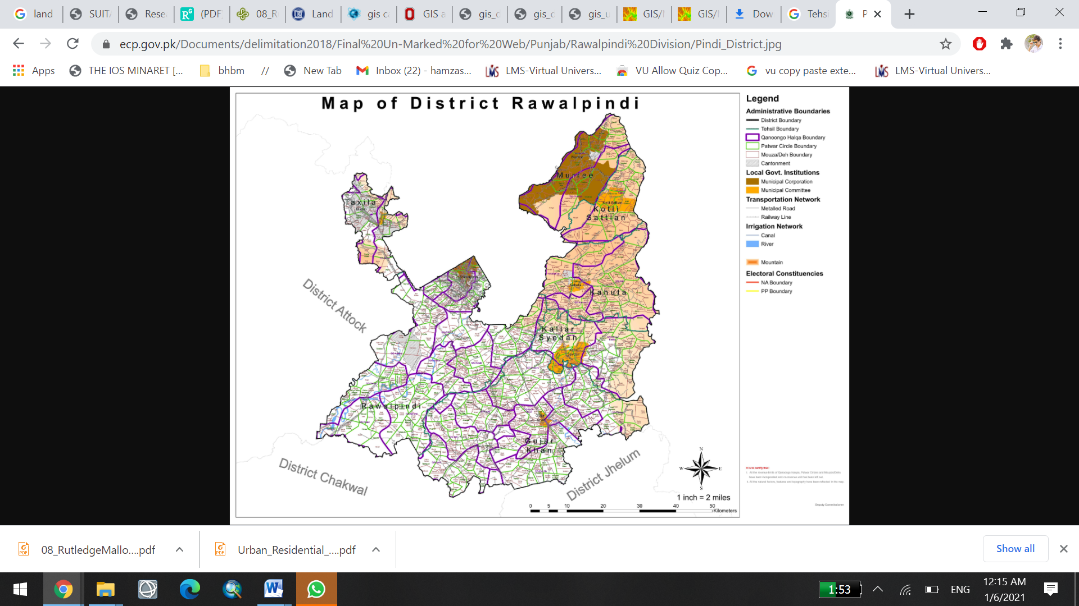

Methodology:

In this study, residential land suitability analysis was conducted with the procedures of land attributes used to depict residential land suitability were generated through image processing and spatial analysis.

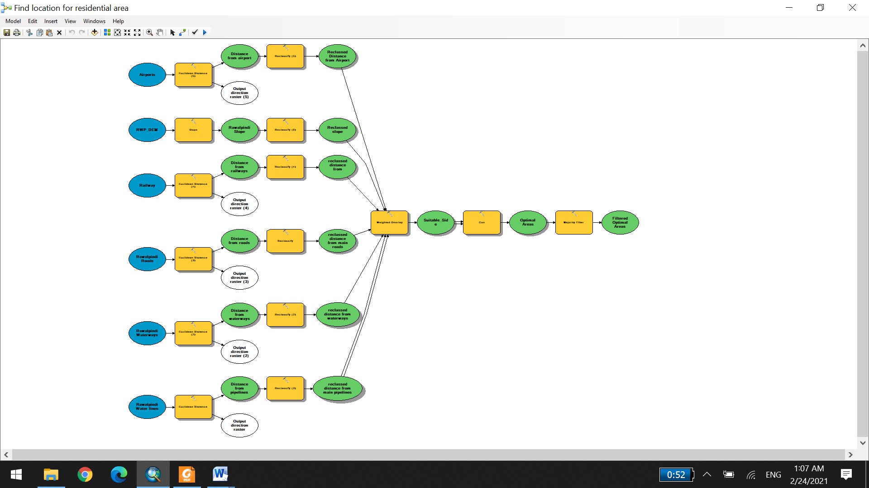

Criteria:

* Must be located in less steep area.
* Must be away a least 1-2 KM from waterways to avoid flood or natural danger.
* Must be accessible to main roads with 2-4 Km distance.
* It should not a wet land.
* Must be away at least 3 Km from land erosion or land degradation area.
* The Opted area must be equal to or greater than at least 1 acre.
* The opted land suitability sites must be comfortable with natural environment factor like slope, soil type geologic hazards present, land cover, etc.,
* The site must have environment factors like existing land use, planned land use, accessibility to roads, availability of utilities, etc.,
* The site must have economic factors like land value, tax rate, etc.
* And Social factors like population present, job present, historical features present.
* Must be accessible to International Airports with the distance of 10 Km.
* It must be environment friendly.
* Must be reachable to Public Sector Health Facilities with the distance of 5 Km.
* Must be reachable to Public Sector Educational institutes with the distance of 5 Km.
* Must be reachable to mass transit system or ring roads stops with the distance of 5 Km.
* Easily accessible to energy sources.
* Reachable to parks or hiking tracks.

Final Map:

